2013 | SIET signed MOU with The Institution of Engineering Designer, UK (IED).  IED is one of the licensing bodies under The Engineering Council, UK.  Suitably qualified members can apply for registration as: Engineering Technician (EngTech), Incorporated Engineer (IEng) or Chartered Engineer (CEng).  [Website: www.ied.org.uk  Website: www.engc.org.uk ]  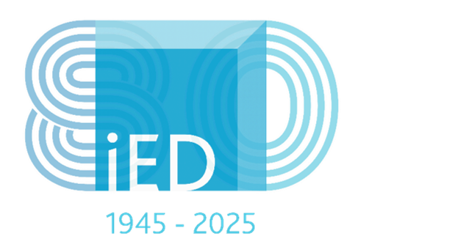
2014 | SIET signed MOU with the Association of British Engineers in Italy. (ABEI).  [Website: www.theabei.eu ]  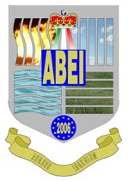
2024 | Signed MOU with the Institution of Incorporated Engineers, Sri Lanka.  Home - IIESL  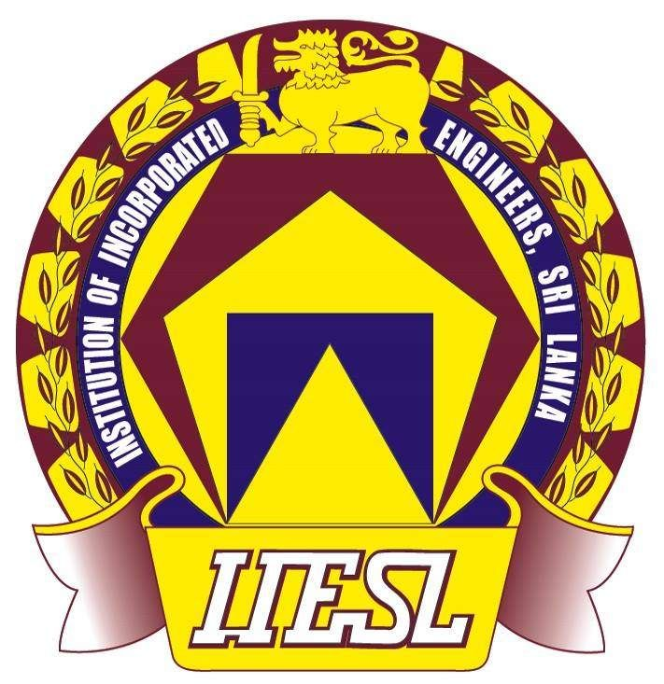
1996 | MOU with the Institute of Professional Engineering Technolgists, South Africa.(IPET)  Website: www.ipet.org.za  
1990 | MOU with Technological Association Malaysia (TAM)  Website: www.tam.org.my  
1991 | Affiliated with the Society of Engineers, United Kingdom (Now merged to form The Institution of Engineering & Technology, UK).  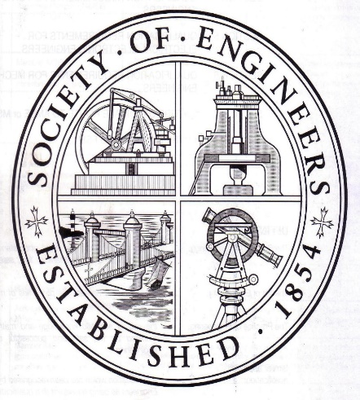    Website: www.theiet.org

